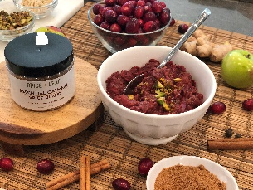

Spiced Cranberry Chutney
By Debbie Kornberg

(Serves 4-6)
This easy to prepare dish and has a wonderful tart flavor and of course is perfect for the Thanksgiving holiday.

Ingredients:
1 lb. Cranberries, fresh or frozen
1/2 cup Brown sugar or Honey or Grade A Maple Syrup
1 cup water
1/4 cup Granny Smith or Honey Crisp Apple, chopped
1 Tbsp. SPICE + LEAF Oatmeal Spice Blend
2 tsp. Ginger, fresh and grated
1/4 cup Pistachios, chopped
1/4 cup Almonds, slivered
1/2 tsp. Orange zest

Instructions:
Using a medium size pot, combine cranberries, sugar, water, apples, SPICE + LEAF Oatmeal Spice Blend, & ginger. Bring to a boil and let simmer for approximately 10 minutes or until cranberries start to breakdown and pop. Add almonds, pistachios and orange zest. Continue to simmer and stir regularly for about 2 minutes. Cranberries should look chunky but soft. Serve with your Turkey on Thanksgiving or use as a condiment for appetizers and serve with cheese and crackers as a topper to add a nice tart and sweet flavor.

