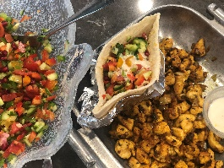

Shawarma Chicken
By Debbie Kornberg

Ingredients:
1.5 lbs. chicken breasts (cut into 1/2 inch cubes)
2 -3 Tbsp. SPICE + LEAF Shawarma Blend
2-3 Tbsp. olive oil SPICE + LEAF Galili Olive Oil
1 medium onion, chopped
10 mushrooms, sliced
Salt to taste

Cooking Instructions:
- In a bowl, place cut chicken and sprinkle shawarma blend over chicken until poultry is fully coated with spice blend. Set aside.
- In a pan, add olive oil and sauté onions (and optional mushrooms). Once onions (and mushrooms) are cooked down, remove from pan place in bowl. Set aside.
- Add 2 Tbsp. Olive Oil to sauté pan, place stove on high heat. Cook chicken ideally getting a nice sear on the outside of chicken and then turn down to slightly lower heat (medium to med-high) and cook chicken all the way through. (Do not cover pan, chicken will get soggy and rubbery.)
- Once chicken is fully cooked, add onions and mushrooms, and mix together. Remove from heat and serve! Shawarma pairs well with roasted potatoes, rice, hummus, cucumber-tomato salad and tahini dressing. Enjoy!

*Vegetarian Alternative: Use Cauliflower Florets. Pre-heat oven to 425 degrees. Coat vegetable with olive oil and sprinkle Shawarma spice on top and roast for until crispy brown on top for about 18 minutes.

Feel like grilling next time? Place cubed shawarma chicken on skewers and use olive oil cooking spray to coat chicken and cook on grill. Also really yummy!

