Roasted Root Vegetables
With 18 Year Aged Balsamic Vinegar
By Debbie Kornberg

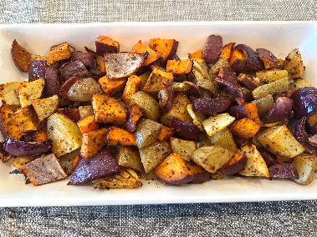

This recipe is a winner every time and perfect for feeding a large group of people or meal prepping for the week.

Serves
Ingredients:
2 Yukon gold potatoes, chopped 3/4 inches
2 Golden beets (medium size), peeled, chopped 3/4 inches
1 Fennel bulb, 3/4 inch pieces
1 Sweet Potato, chopped 3/4 inches
1 Red onion, small - medium size, chopped 3/4 inches
3-4 Tbsp. Olive Oil Recommend - SPICE + LEAF Premium Israeli Olive Oil (Available on Amazon)
1 Tbsp. SPICE + LEAF Rosemary Garlic Salt (Available on Amazon)
1 Tbsp. SPICE + LEAF Roasted Vegetable (Available on Amazon)
Thick Balsamic for drizzling, Recommend -SPICE +LEAF 18 Year Aged Dark Balsamic (Available on Amazon)

Instructions:
- Preheat oven to 425 degrees.
- Peel and cut all vegetables into 3/4 inch pieces.
- In a large bowl, combine all prepped vegetables. Add Rosemary olive oil with Roasted Vegetable Blend and Rosemary Garlic Salt.
- Mix all together and then transfer onto a baking sheet with parchment paper. Arrange the vegetables evenly for even cooking.
- Roast at pre-heated oven to 425 F. Roast for 35 to 40 minutes until vegetables are cooked through.
- Immediately transfer into a heat proof serving dish to keep warm.
- For the finishing touch, drizzle balsamic over the roasted root vegetables to compliment the flavor and for a beautiful presentation!

